Chapter 19, Problem 38.

The h parameters of the two-port of Fig. 19.95 are:
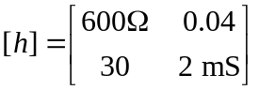

Given the Z_{s} = 2 kΩ and Z_{L} = 400 Ω, find Z_{in} and Z_{out}.

Z_{s}

[h]
+
_
+ +
V_{s} V₂
V1 – Z_{L}
–

Z_{in} Z_{out}

Figure 19.95
For Prob. 19.38.

